**ETL Project (Magic the Gathering ETL)**

**Gibran Ahmad** **∙ Paul Dean ∙ Soobin Hwang ∙ Seunghwa Jun**

**EXTRACT** (Original Data Sources and Formats)

* **Magic The Gathering (MTG, collectable card games) from Kaggle**
* Source : <https://www.kaggle.com/mylesoneill/magic-the-gathering-cards>
* Format : JSON file ("./AllCards.json")
* **Card Price (War of the Spark)**
* Source : https://www.mtggoldfish.com/index/XLN_GRN#paper
* Format : HTML file (pd.read_html)

**TRANSFORM** (Data Cleaning or Transformation Process)

* **① Use ‘pd.read_json’ to create a DataFrame of the cardinfo data**
* json_file = "./AllCards.json"
* mtg_df = pd.read_json(json_file)
* **② Tanspose the data, so that the card names go down vertically and into the index**
* mtg_df = pd.DataFrame(mtg_df.transpose())
* **③ Clean up the dataframe, select and rename columns**
* clean_mtg_df = mtg_df[["index","convertedManaCost", "text", "type"]]
* clean_mtg_df = clean_mtg_df.rename(columns={"index":"cardname"})
* **④ Use pd.read_html to create a Dataframe of the price information data**
* price_url = 'https://www.mtggoldfish.com/index/XLN_GRN#paper'
* price = pd.read_html(price_url)
* **⑤ Remove the first two rows of the dataframe as they are not relevant**
* price_table = price[2:].copy()
* df = pd.DataFrame(price_table[0])
* **⑥ Select columns that are relevant and set ID.**
* clean_price_df = df[['Card', 'Price']]
* clean_price_df.index.name = 'id'

**ETL Project** (2/2)

**LOAD** (Final Database and Tables)

* **Create SQLite database and Push Data inti it**
* Import sqlalchemy and connecting to DBS
* Import methods needed to abstract classes into tables
* Declare column types
* **Set up a connection to the database**
* **Create the tables associated with the classes**
* **Push the pandas dataframe into the SQLite database**
* clean_mtg_df.to_sql('cardinfo', con=engine, if_exists='replace')
* clean_price_df.to_sql('priceinfo', con=engine, if_exists='replace')
* **Create another engine for postgres and rename table names**
* Rename the colums to all lower case and appending cardinfo table
* Rename columns to all lower case and appending priceinfo table ‘
* **Joining Queries to do trend analysis and to uncover opportunities for profit**
* As MTG card players, we want to be able to analyze card price trends based on various metrics, such as converted mana cost and type. Combining these two databases would allow us to do trend analysis on these metrics, potentially allowing us to uncover opportunities for profit. There is a large “second-hand” market for sale and purchase of MTG card singles – we would be able to get a better sense of which cards are under- and over-priced.

**ETL Project** (Attached Images 1/2)

**Captured Images** (Postgres Tables)

**[ Cardinfo table ]**

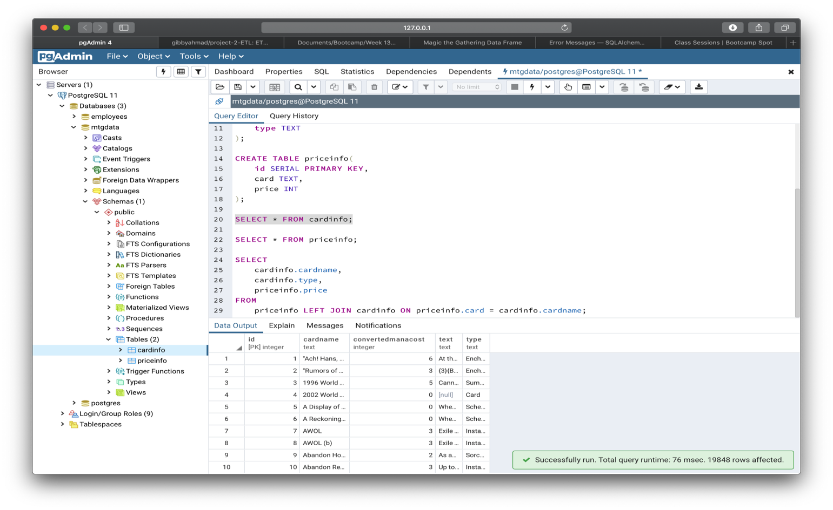

**[ Priceinfo table ]**

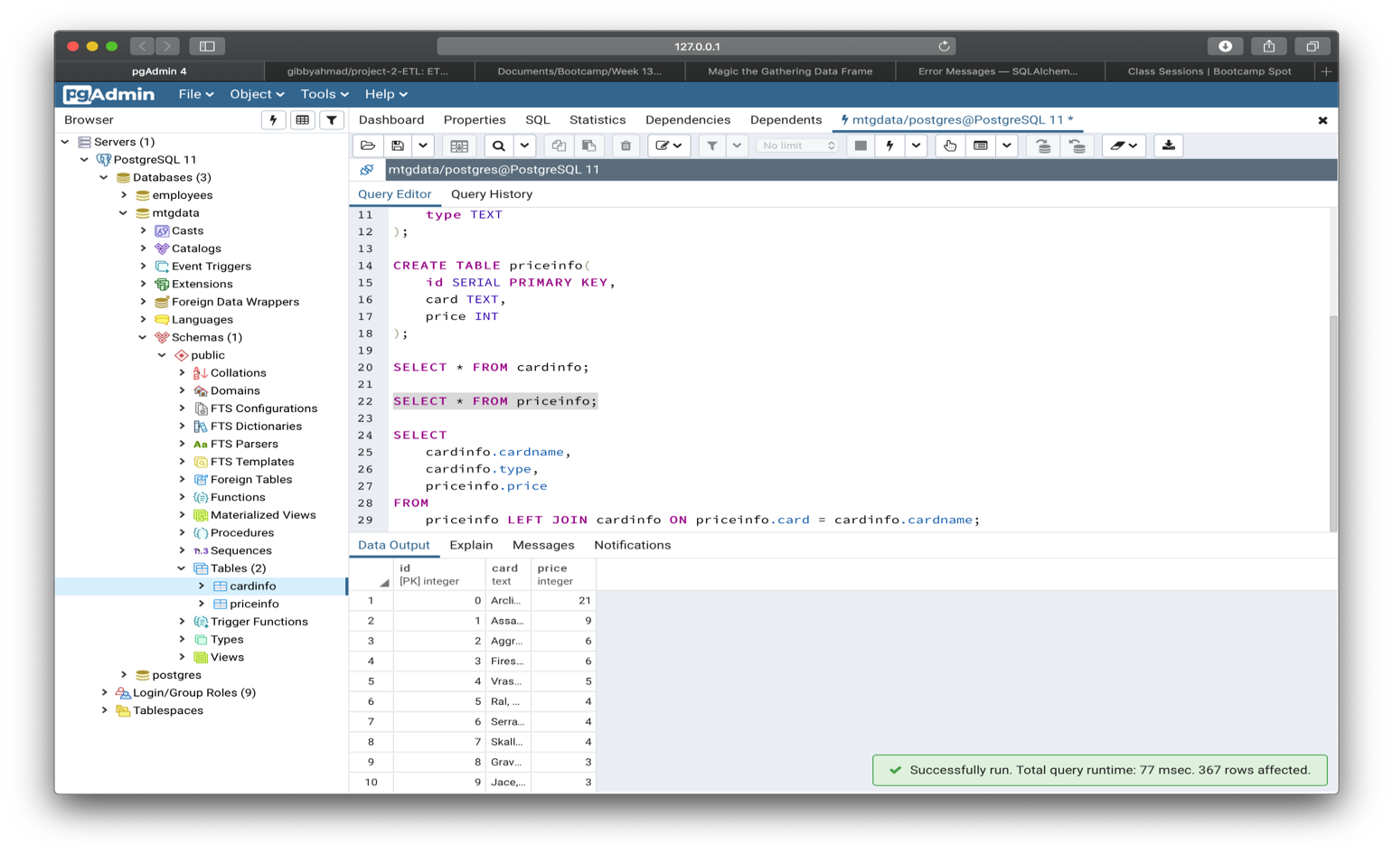

**ETL Project** (Attached Images 2/2)

**[ Joining Query ]**

